JavaScript

>alert(“Hello World”);

>console.log(“Hello world”);

>Calculations can be done directly.

>document.querySelector(“gN089b”) // google.com

>document.querySelector(“gN089b”).click()

>document.getElementById(“bd-versions”).click() // Bootstrap.com

Basic Requirement to build a website: HTML(Basic Skeleton),CSS(Designing)& JS(client side scripting).

HTML : > It stands for Hypertext Markup Language.

>It is basically a standard markup language for giving a static skeleton to web application and websites.

>It’s a well standardized system.

CSS: >Cascading Style Sheets which is known as CSS is a style sheet language that used to handle the presentation of the web page containing HTML.

>It makes our websites beautiful and modern looking.

JS: > JavaScript is a high-level dynamic interpreted programming language.

>It allows client-side scripting to create completely dynamic web applications and websites.

* JS was initially designed for making pages “alive”
* Scripts can be executed in the browser itself.
* JS and Java are different programming languages.
* It can be executed on the browser as well as the server
* JavaScript is a safe language when used in browser
* There are languages that get “ transpiled” to JS ex: Coffee script, Typescript,Brython.

Pre- setup:

* Install the VS code
* Create a folder
* Open with vs code within the folder.
* Create a index.html file.
* Write the basic html tag by the help of Emmet Abbreviation (!)
* Go to extensions and install Live server and enable it the code is ready to execute in the browser.
* JavaScritp code is always written between the script tag and placed inside of body. Ex:

<script>

    console.log("Hello world");

    alert("me")

</script>

* div.container // Emmet Abbrevation, it is a class.
* button#click // <button id=”click”></button>

Id’s are always unique.

Class can be used any number of times

DOM manipulation: Using JS to make changes with the HTML and CSS page contents.

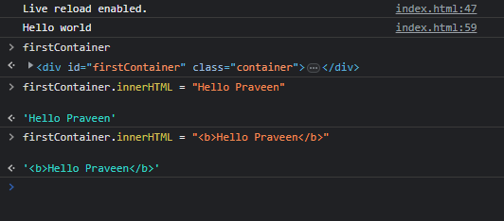

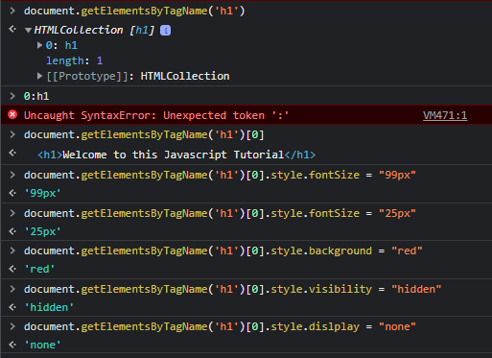

* console.clear() // clears the console window.
* console.error(“this is error”)
* console.warn(“displays warining”)
* document.write(“writes on document”)
* console.assert(4==6)
* script:src // while including the JS file externally.
* elemClass[0].innerHTML // gives out html code as string.
* elemClass[0].innerText // only text is shown.
* document.location
* document.title
* document.URL
* document.scripts
* document.links
* document.images
* document.domain

